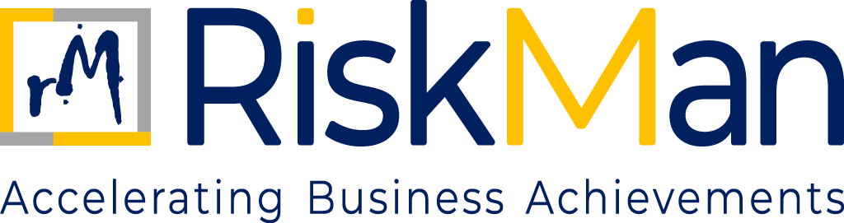
Anti-Money Laundering Policy
TABLE OF CONTENTS
Anti-Money Laundering Policy

- Objective……………………………………………………………………………………………………………………….…………3
- Definition of Money Laundering…………………………………………………………………………………….…………3
- Know Your Customer (KYC) Commitment……………………………………………………………………….…………3
- Internal Controls and Audit Mechanisms………………………………………………………………………………….3
- Training and Awareness……………………………………………………………………………………………………………3
- Reporting of Suspicious Transactions………………………………………………………………………………..………4
- Culture and Values……………………………………………………………………………………………………………..…….4
- Review and Amendments…………………………………………………………………………………………………………4
ANTI-MONEY LAUNDERING (AML) POLICY
- OBJECTIVE
RiskMan Consulting is committed to the highest standards of ethical and lawful conduct in all its business operations. This Anti-Money Laundering (AML) Policy outlines the principles and procedures that guide our efforts to prevent the use of our services for money laundering, terror funding, and other forms of financial crimes.
This policy is established to:
- Prevent RiskMan Consulting’s systems, employees, services, or reputation from being misused in money laundering or terror funding activities.
- Ensure compliance with relevant laws and regulatory requirements including the Prevention of Money Laundering Act (PMLA), 2002 and global best practices.
- Promote transparency and accountability in all financial and operational dealings.
- Reinforce our culture of integrity, diligence, and risk awareness.

- DEFINITION OF MONEY LAUNDERING
Money laundering is the process of disguising the origins of illegally obtained money so that it appears to be legitimate. It typically involves three stages:
- Placement: Introducing illicit funds into the financial system.
- Layering: Concealing the source of the funds through complex transactions.
- Integration: Re-introducing the laundered money into the legitimate economy as clean funds.

Money laundering can be linked to various criminal activities such as corruption, fraud, tax evasion, terror funding, drug trafficking, and organized crimes.

- KNOW YOUR CUSTOMER (KYC) COMMITMENT
RiskMan Consulting is fully committed to the principle of “Know Your Customer” (KYC). As part of this commitment:
- All clients, vendors, and partners will undergo appropriate due diligence before any business relationship is established.
- Customer identification and verification shall be conducted through reliable and independent documentation and data sources.
- Enhanced due diligence measures will be applied for high-risk clients or transactions, including politically exposed persons (PEPs) or those in high-risk jurisdictions.
- Continuous monitoring of transactions will be performed to detect suspicious behaviour.

- INTERNAL CONTROLS AND AUDIT MECHANISMS
To maintain AML compliance:
- Periodic internal audits will be conducted to assess the effectiveness of our AML controls and adherence to applicable laws.
- RiskMan Consulting will maintain up-to-date records of all relevant transactions and customer interactions in accordance with statutory requirements.

- TRAINING AND AWARENESS
- All employees will receive regular training on AML regulations, red flag indicators, and internal reporting mechanisms.
- Training programs will be tailored to employee roles to ensure they understand their responsibilities and can identify and escalate suspicious activity.

- REPORTING OF SUSPICIOUS TRANSACTIONS
- Employees are obligated to promptly report any suspicious transactions or activities to the Compliance Officer.
- RiskMan Consulting will cooperate fully with regulatory and law enforcement authorities, ensuring that suspicious transaction reports (STRs) are filed in accordance with legal obligations.
- Confidentiality will be maintained throughout the reporting process, and whistleblowers will be protected against any form of retaliation.

- CULTURE AND VALUES
RiskMan Consulting fosters a culture of compliance, ethical behaviour, and zero tolerance for financial crime. We believe that integrity, transparency, and accountability are not only regulatory obligations but also fundamental values that define how we do business.

All employees, partners, and stakeholders are expected to uphold these values and actively contribute to the prevention of money laundering and other financial crimes.

- REVIEW AND AMENDMENTS
This AML Policy will be reviewed as and when needed or more frequently if required by changes in legislation, risk profile, or regulatory expectations. Any amendments will be communicated to all relevant stakeholders.

